Chapter 8
FET Amplifiers
Objectives
- Explain the operation and amplification properties of FET amplifiers
- Explain and analyze the operation of common-source, common-drain, and common-gate amplifiers
Introduction
FET amplifiers are similar to BJT amplifiers in operation. The purpose of the amplifier is the same for both FET amplifiers and BJT amplifiers. FET amplifiers have certain advantages over BJT amplifiers such as high input impedance. However, the BJT normally has a higher voltage gain.
There are also similarities in the three amplifier configurations of FETs and BJTs. Common-source (emitter), common-drain (collector), and common-gate (base) are the three FET amplifier configurations.
FET Amplification
Let’s first look at an equivalent FET circuit to better understand its operation. The FET is basically a current source that is controlled by V_{GS}. Note that the resistance from gate to source can be neglected since it is so large in value and in most cases the drain to source resistance (r_{ds}) can be neglected as well.
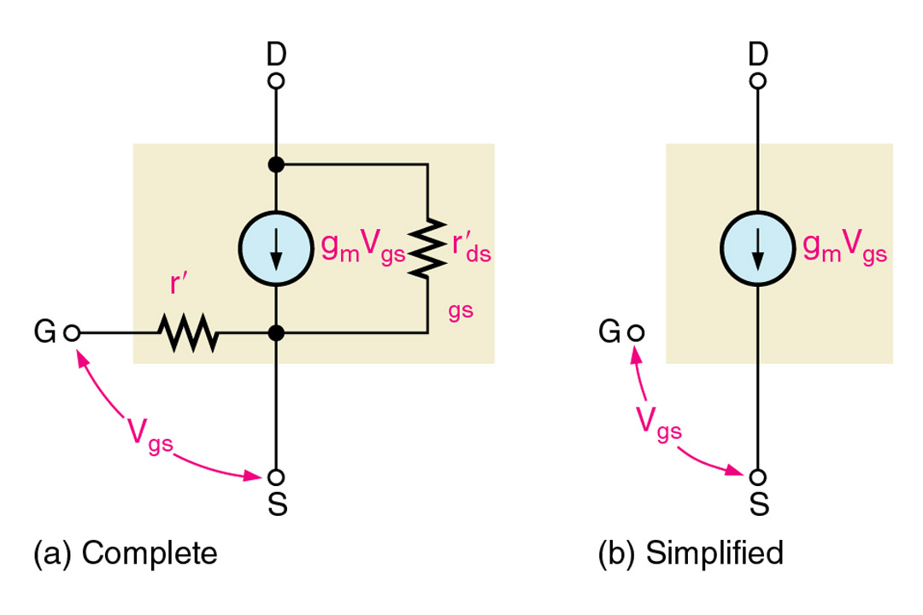
I_{D} = g_{m}V_{GS} (g_{m} is the symbol for transconductance)
FET Amplification
Voltage gain (Av) for any amplifier can certainly be determined by the formula
A_{V} = V_{out}/V_{in} or in the case of an FET amplifier, A_{V} = V_{ds}/V_{gs.} A_{V} can also be determined by way of the transconductance and the drain resistor.
A_{V} = g_{m}R_{D}
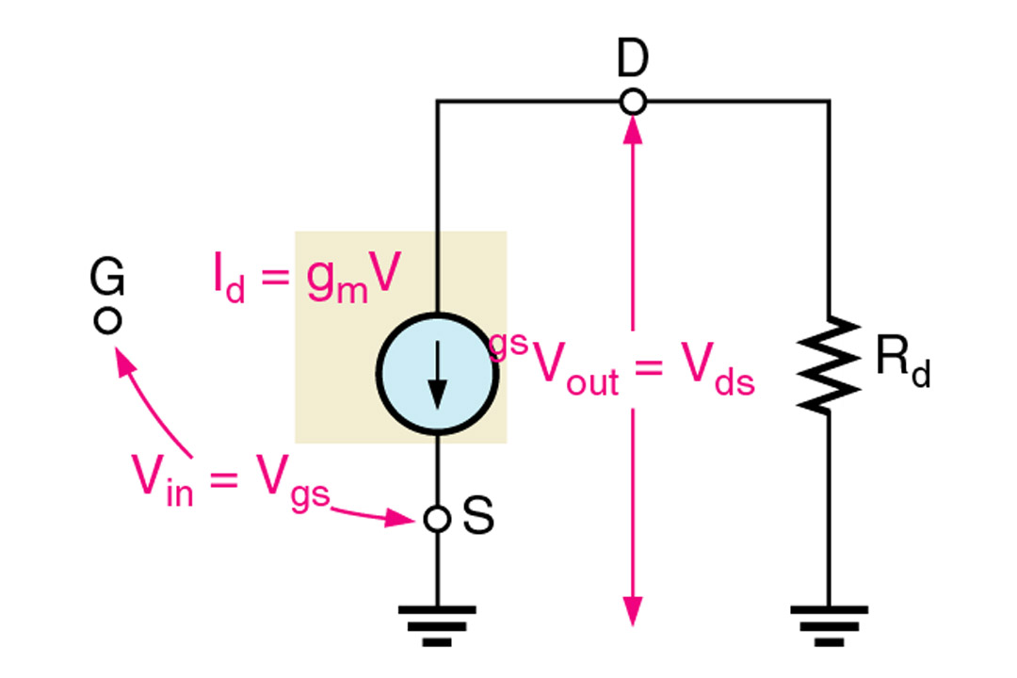

The r_{ds} can lower the gain if it is not sufficiently greater than R_{D}. Note that the two resistances are in parallel.
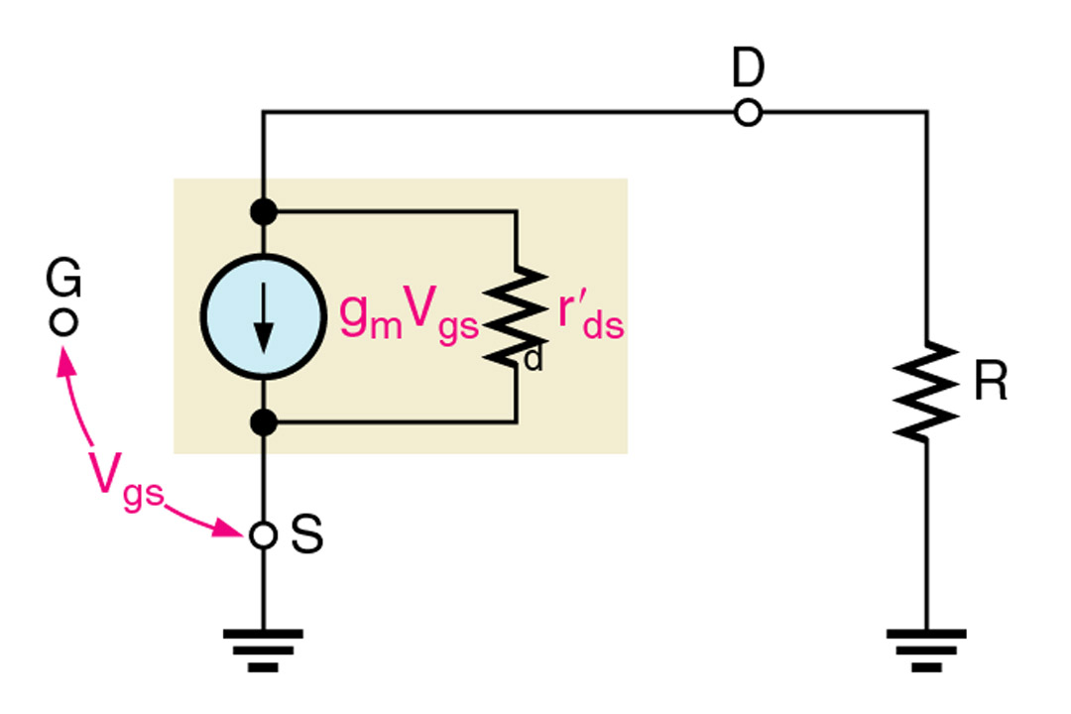

R_{S} can affect the gain as well. The gain is lowered with higher values of R_{S} and decreases with higher values of R_{S}. The formula below shows the relationship.
A_{v} = g_{m}R_{D}/1+g_{m}R_{S}
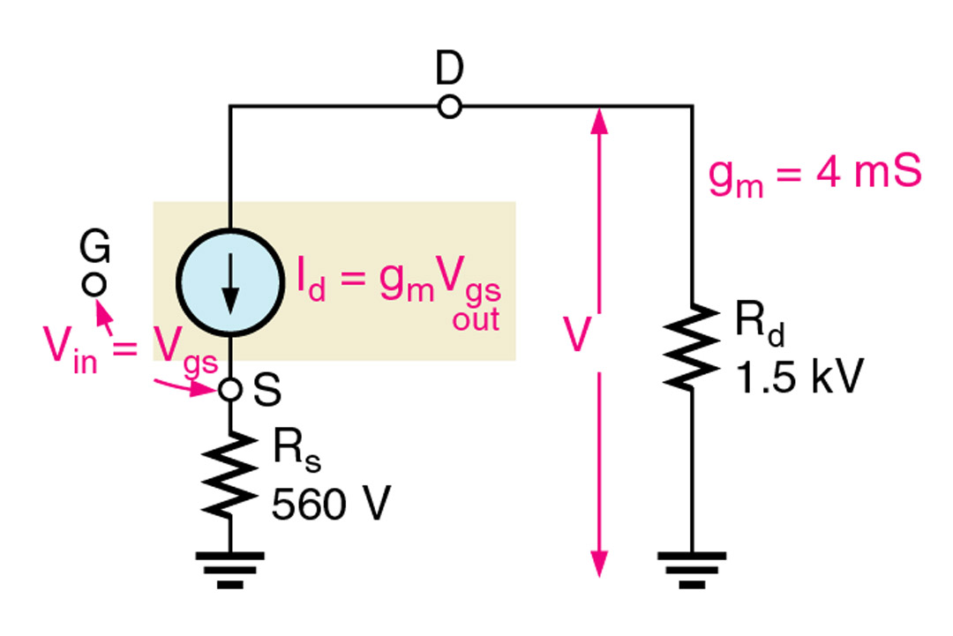

Common-Source Amplifiers
The common-source amplifier is biased such that the input stays within the linear range of operation.
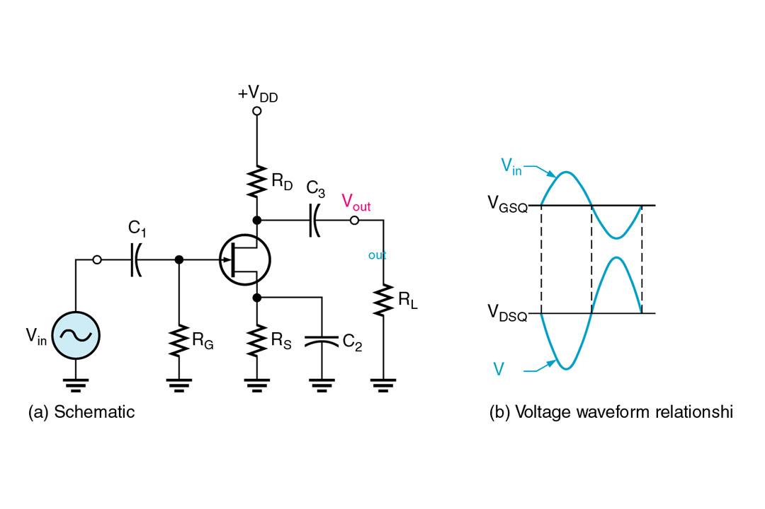

Self biased common source amplifier. Note the source is at ac ground by way of C₂.
The transfer characteristic curve and drain curves with load line give us a graphical representation of how the input signal affects the drain current with relation to the
Q-point.
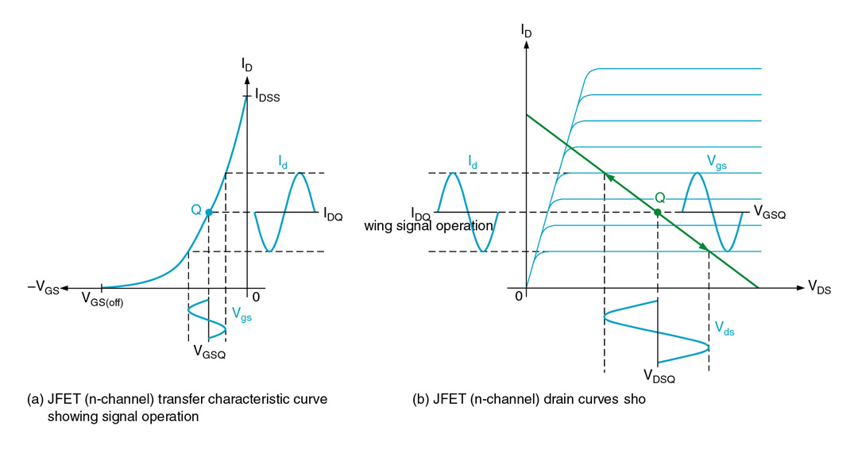

DC analysis of a common-source amplifier requires us to determine I_{D}. Biasing at midpoint is most common so I_{D} will be half of I_{DSS}. Note that the capacitors are viewed as open components when only dc is considered.
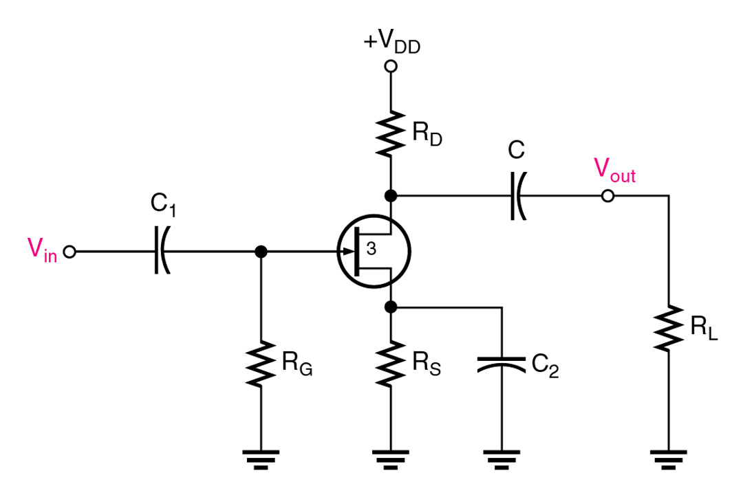

With ac equivalent circuit analysis we view the capacitors effectively as shorts. Notice that the source is at ground and R_{D} and R_{L} are in parallel.
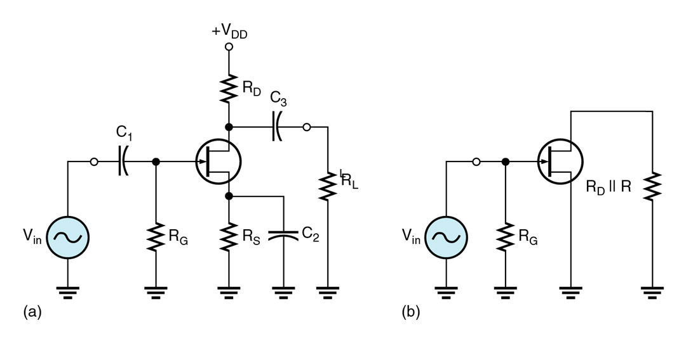

The load (R_{L}) must be considered when viewing the ac equivalent circuit of an FET amplifier, R_{L} is in parallel with the drain resistor (R_{D}). This will lower the gain by lowering the overall drain resistance which is represented by R_{d}. Calculation for R_{d} can be determined by parallel resistance calculation methods. Once R_{d} is determined the voltage gain can be determined by the familiar gain formula below.
A_{v} = g_{m}R_{d}
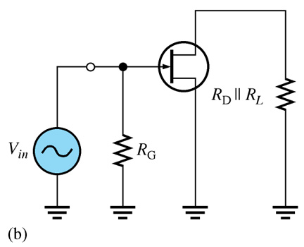

D-MOSFET Amplifier Operation
With this zero biased D-MOSFET amplifier it is quite easy to analyze the drain circuit since I_{D} = I_{DSS}.
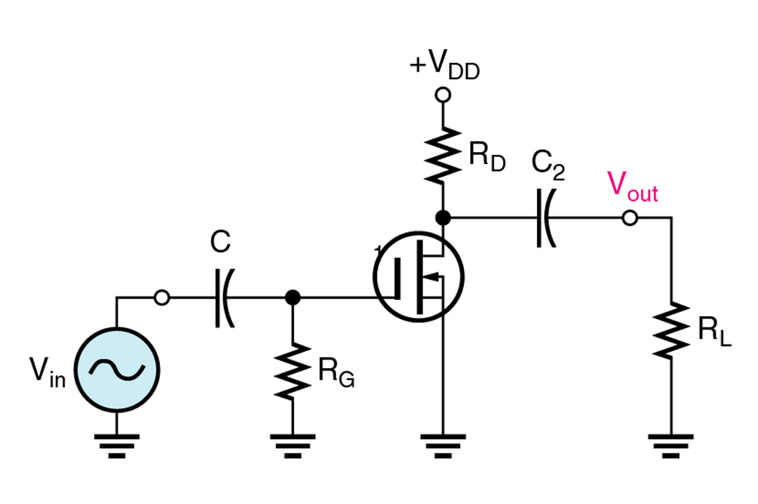

D-MOSFET Amplifier Operation
With a zero-biased D-MOSFET amplifier the swings occur in both enhancement mode and depletion mode. The methods for ac analysis for the D-MOSFET amplifier are identical to the JFET amplifier discussed previously.

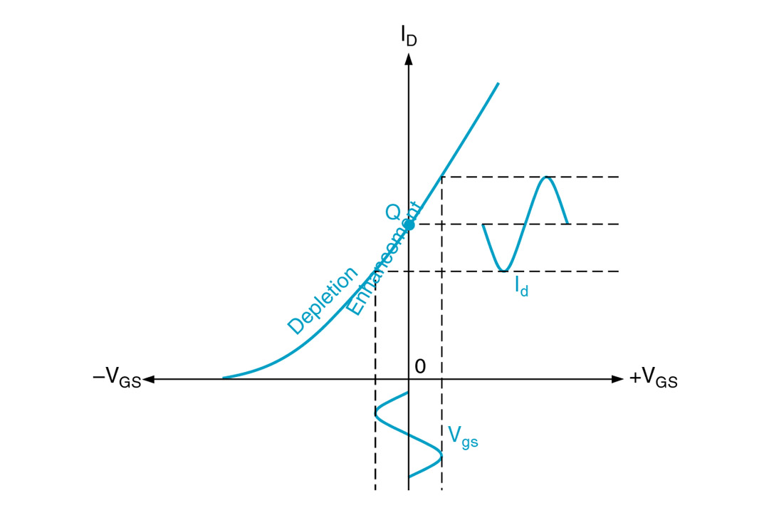

E-MOSFET Amplifier Operation
For a voltage-divider biased E-MOSFET circuit the voltage divider sets the V_{GS} needed to set the Q-point above the threshold. DC analysis of the drain circuit requires determination of the constant (K) from the formula discussed in the previous chapter.
K = I_{D}(on) /(V_{GS} - V_{GS}(th))²
I_{D} = K(V_{GS} – V _{GS}(th))²

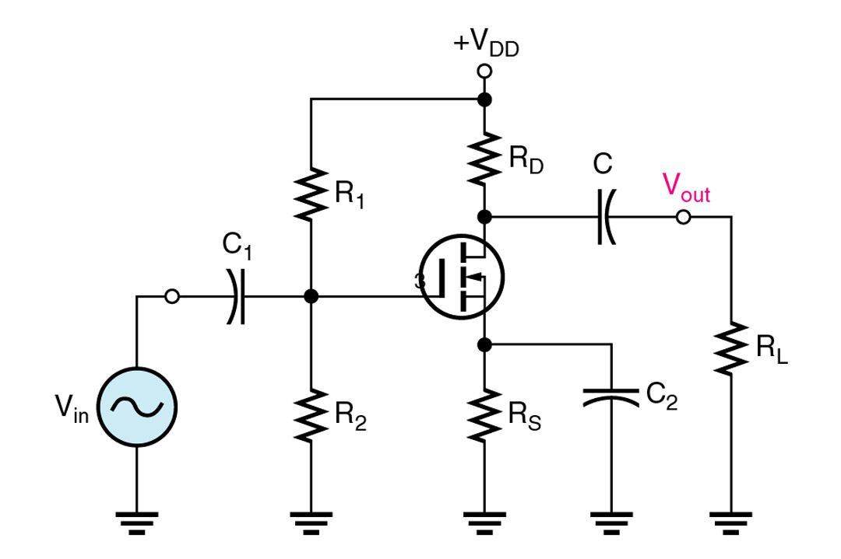

E-MOSFET Amplifier Operation
Notice that with the E-MOSFET amplifier operation occurs exclusively in the enhancement mode. Voltage gain calculation for the E-MOSFET amplifier is the same as the JFET and D-MOSFET.
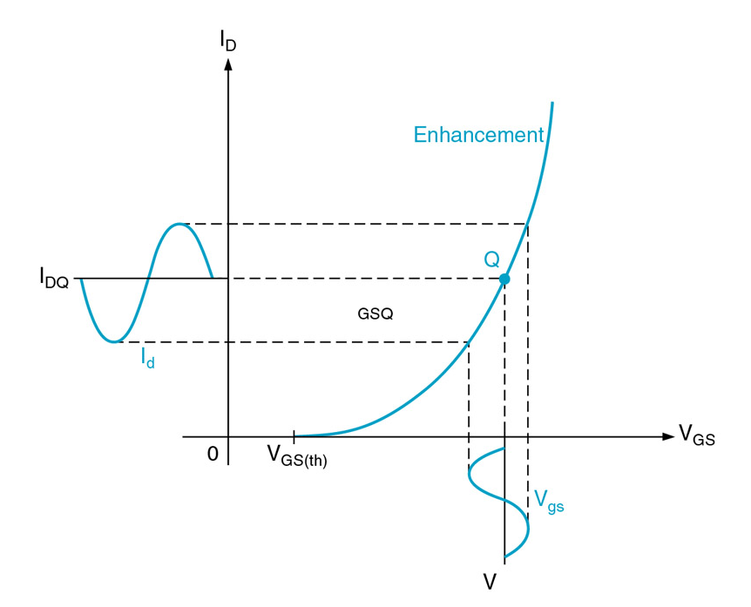

Common-Drain Amplifiers
The common-drain amplifier is similar to the common-collector BJT amplifier in that the V_{in} is the same as V_{out} with no phase shift. The gain is actually slightly less than 1. Note the output is taken from the source.
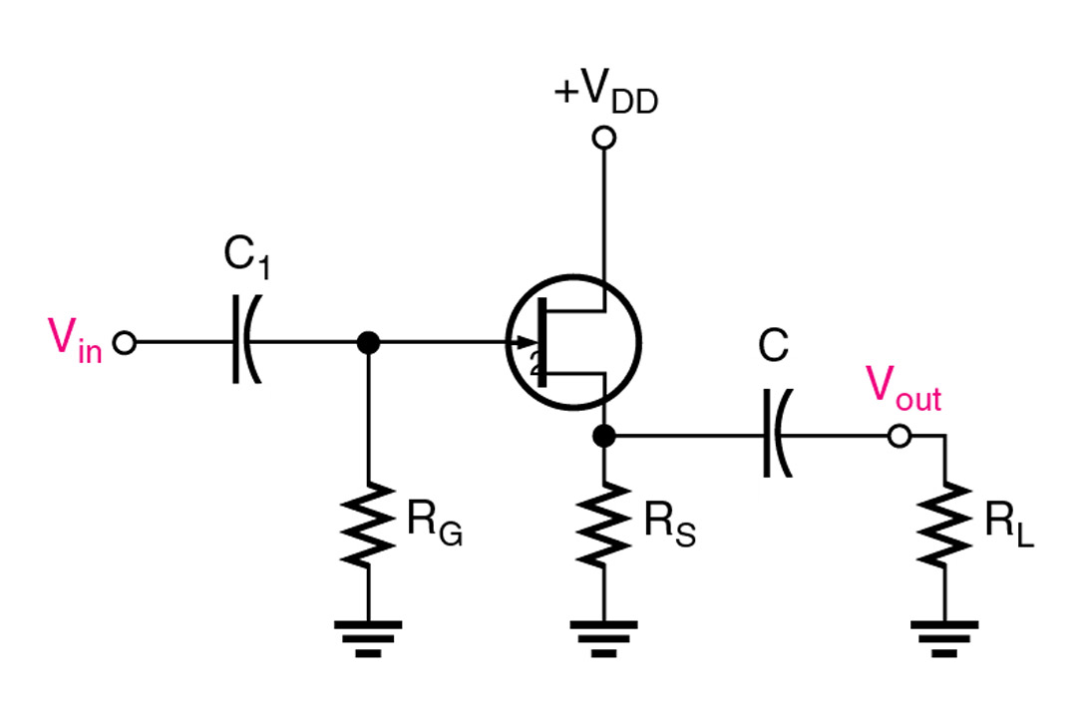

Common-Gate Amplifiers
The common-gate is similar to the common base BJT amplifier in that it has a low input resistance. The voltage gain can be determined by the same formula as used with the JFET common-source amplifier. The input resistance can be determined by the formula below.
R_{in} (source) = 1/g_{m}
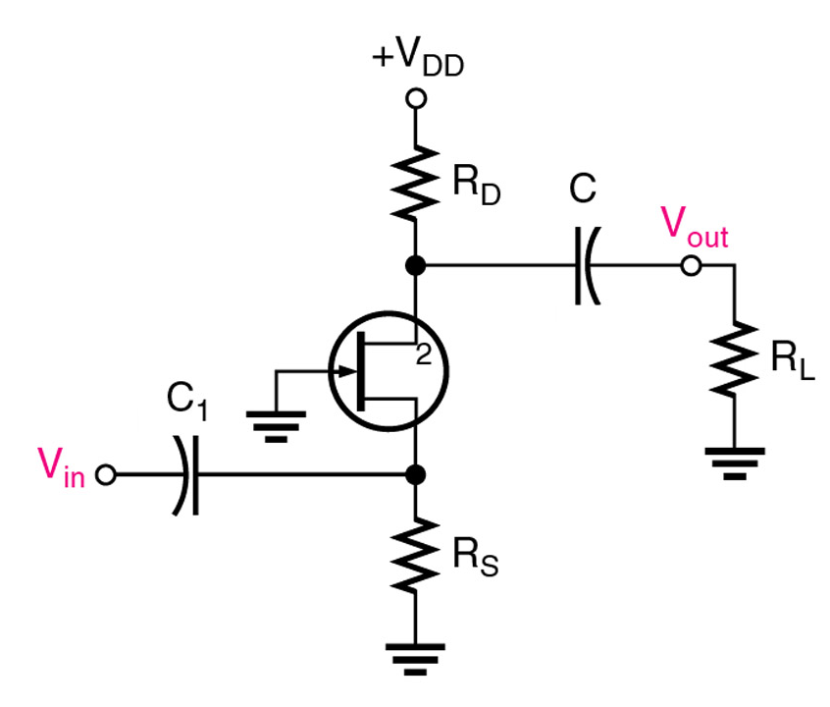

Summary
- FET amplifier configuration operations are similar to BJT amplifiers.
- The transconductance (g_{m}) relates the drain current (ac output) to the ac input voltage (Vgs)
- Gain can be affected by drain circuit resistance.
- The input resistance for a FET at the gate is extremely high.
- The common-source is the most used type of FET amplifier and has a phase inversion is 180º.
- The common-drain has no phase shift, a gain slightly less than 1, and the output is taken from the source.
- The common-gate has no phase shift and low input resistance.

